Article Title (Times New Roman, 16pt, Boldface)
Firstname Lastname^{1*}, Firstname Lastname ², Firstname Lastname ^{3*} (Times New Roman, 10pt)
¹Affiliation, E-mail:
² Affiliation, E-mail:
³ Affiliation, E-mail:
* Correspondence E-mail:
科技部計畫名稱: (若無科技部經費贊助，請刪除)
科技部計畫編號: MOST XXX-X-XXX-XX (若無科技部經費贊助，請刪除)

Abstract: The abstract uses Times New Roman 10 pt. A single paragraph of about 200 words maximum. The abstract should address the research motivation, research method, key results, and conclusions. The research motivation places the question addressed in a broad context and highlight the purpose of the research. The research method describe briefly the main methods applied. The key results summarize the main findings in this article. The conclusion draws together the most important results and their consequences and list any reservations or limitations.
Keywords: keyword1，keyword2，keyword3 (List 3 to 10 pertinent keywords specific to the article).
1. Introduction (Times New Roman，Boldface，10pt)
The main text uses Times New Roman 10pt. The article must be at most 2 pages. The introduction section should (1) brief the scope and objective of the paper and state the problem, (2) briefly review the pertinent literature, (3) brief the methods, and (4) provide an overview of the main results of the work. References should be numbered in order of appearance and indicated by a numeral or numerals in square brackets, e.g., [1] or [2,3], or [4–6]. See the end of the document for further details on references.
2. Materials and Methods
The methodology must be briefly stated and described or with sufficient references. It should be furthermore highlighted why the research problem is relevant to theory and practice, and why the chosen method(s) are suited for the problem. Equations shall be written in centered numbered, as shown in Eq. (1),
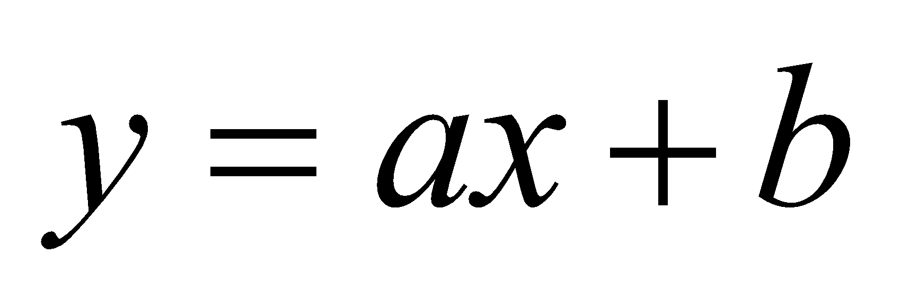. | (1)
3. Results and Discussion
This section presents the output of the experiments, model, or computation. Give emphasis in the text the most important aspects of the tables, graphs, or figures. All figures and tables should be cited in the main text as Figure 1, Table 1, etc.
  (a) | (b)
Figure 1. Figure caption uses Times New Roman 9pt: (a) Figure description, (b) Figure description.
Table 1. Table caption uses Times New Roman 9pt. Tables should be placed in the main text near to the first time they are cited.
Title 1 | Title 2 | Title 3
Entry 1 | data | Data
Entry 2 | data | Data

This is an example of equation:
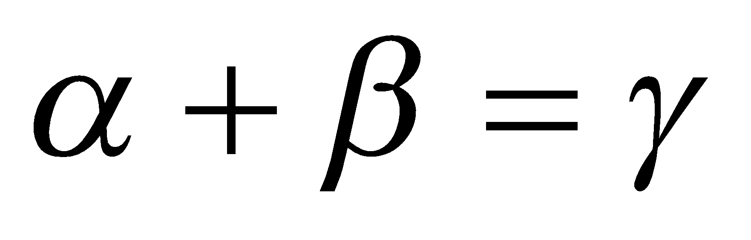, | (2)
the text following an equation need not be a new paragraph. Please punctuate equation as regular text.
4. Conclusions
This section draws together the most important results and their consequences. Do not duplicate the Abstract as the Conclusions or vice versa. The Abstract is an overview of the entire paper. The Conclusions are a summing up of the advances in knowledge that have emerged from it.
Acknowledgement
You can acknowledge any support, such as ideas, technical assistance, materials, or finance, given by the individual or organization.
References
- F. Forster, "A high-resolution and high accuracy real-time 3D sensor based on structured light," in Proceedings of theThird International Symposium on 3D Data Processing, Visualization, and Transmission, 208-215, 2006.
- D. Baek, S. Cho, and H. Bang, "Wheel alignment inspection by 3D point cloud monitoring," Journal of Mechanical Science and Technology, 28 (4), pp. 1465-1471, 2014.
- D. Knowles, Today's technician – shop manual for automotive suspension & steering systems, Fourth ed. New York, USA: Thomson Delmar Learning, 2007.

